Week in Review October 12 - October 24, 2001
Alex Shvartsman

Grand Prix-Montreal
Just under 300 players attended Grand Prix-Montreal, a relatively light turnout for a North American Grand Prix, which nevertheless did not prevent it from being an excellent event. Top pros from all corners of United States attended the event. Surprisingly, many of the top Canada players were missing.
Matt Vienneau, clearly the most successful Canadian Grand Prix player remained in South Africa for several weeks after the Magic Invitational. Gary Wise recently moved to England. Terry Tsang, Jay Elarar and Ryan Fuller weren't there for reasons unknown to me. Best-known Canada players present were Gab Tsang and Gary Krakower. They did not disappoint, both placing in Top 32.
Local players' greatest fear was the repeat of Grand Prix-Toronto, where players from USA took all of the Top 8 slots, edging out players from the hosting country. Although U.S. players were plentiful at the top of the standings, David Rood and Louis Boileau defended Montreal's honor. Rood won a Trial and managed to be the only amateur player in the Top 8, earning more prize money than the eventual winner.
There are several young players in Top 8 of this Grand Prix that are worth watching closely. Louis Boileau finished second in this tournament, and recently made Top 8 in Detroit. These are the only two Grand Prix tournaments he ever played in. Boileau also has a Top 8 in Canadian Nationals - a very impressive beginning to his Pro career. Brett Shears won Grand Prix-Denver after taking a sabbatical from Magic for over a year and now Top 8'ed here, showing he can play Limited as well as Constructed. Peter Szigeti earned his first individual Top 8 after winning GP-Turin with Dan Clegg, who incidentally also finished in Top 8 here. Tim McKenna has played a number of Pro Tours and even earned a Top 16 finish in LA, but this is his first career Top 8 as well. All of these players are among the latest generation of pros who will challenge the Finkels and Buddes of professional Magic in the upcoming Pro Tours this season.
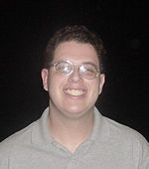
This Top 8 was not without high profile finishers either. Dan Clegg, who can easily be counted among the top 10 players in the world based on his performance in recent months, did not disappoint here, earning a Top 8 finish. Bob Maher showed that he is still a major force by earning a Top 8 finish as well. But it was Mike Turian, possibly the best-liked player on the Pro Tour by his peers, who took home the gold. Turian is a member of PT-NY winning team Potato Nation and has earned a number of Top 16 finishes in individual Pro Tours. This is his first individual win, and a third Grand Prix Top 8 finish to date.
Brian Davis and David Humphreys finished ninth and tenth respectively, both continuing their success streaks from Grand Prix-Minneapolis.

Grand Prix-Shizuoka
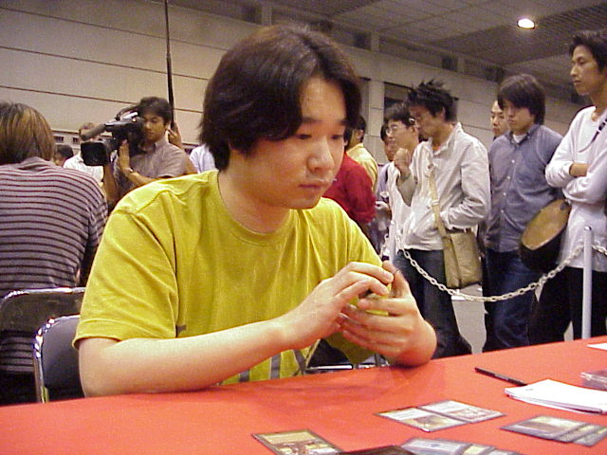
Champion Kohei Yamadaya
The greatest question for anyone following the tournament circuit about the upcoming GP-Shizuoka was: will it become the second Japanese Grand Prix in a row to entice over 1000 participants? The answer was no, but Shizuoka did attract about 750 players - a fairly standard-sized tournament for Japan. Experts say that we might see over 1000 people show up at the next one, in Sendai.
Olivier Ruel and I were the only pros from outside the region to attend the event. I started out strong on Day 1, but managed only a 3-3 performance on the second day, falling to 40th place. Olivier Ruel on the other hand, fought his way through the Swiss to earn a 4th place finish overall. Ruel did not plan his trip in advance - he walked over to a travel agency to inquire about travel fares to Brisbane, and was able to find a bargain on a flight to Tokyo instead. He was willing to travel on short-notice, and even to spend the night before the tournament in front of the venue (Tsuyoshi Fujita was kind enough to bring him a blanket). Ruel's main goal for the tournament was to earn several extra Pro points in order to qualify for the Masters tournament in San Diego. A fourth place finish fit his goals perfectly.
Other notable Top 8 finishers include Tsuyoshi Douyama and rookie of the year Katsuhiro Mori, who is certainly in the running for the title of the most successful Japanese pro player. It was the relatively unknown Kohei Yamadaya who was able to run the table and earn first place despite drafting a three-color deck.

Grand Prix-Brisbane
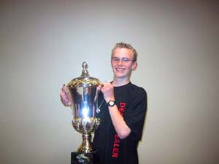
Richard Johnston with a HUGE trophy.
The smallest of the Grand Prix held in recent weeks, GP-Brisbane gathered around 200 players - most from Australia, with around 30 people traveling from New Zealand. Brisbane's resident and the one-time World Champion Tom Champheng did not attend the tournament, and neither did Sam Ward. Most of the other Australian players known outside of their country were present. Rod Ho earned a 12th place finish despite being out of the game for a while. Dane Coltman was not as fortunate, finishing at the bottom of the standings on Day 2. Ben Seck, the most heavily favored Australian player, fell victim to poor mana draws and missed Day 2.
I managed a 3rd place finish, breaking an almost year-long dry streak of missing out on GP Top 8's. This is my 12th Grand Prix Top 8 finish, still the world record. I lost to a young Australian Richard Johnston, who went on to defeat New Zealand's Roger Miller in order to keep the title in Australia. This is a repeat New Zealand-Australia battle for the title. In GP-Sydney, New Zealand's Gordon Lin won the title. This time around, Australia kept it home.

Aaron Forsythe to Join Wizards of the Coast Staff
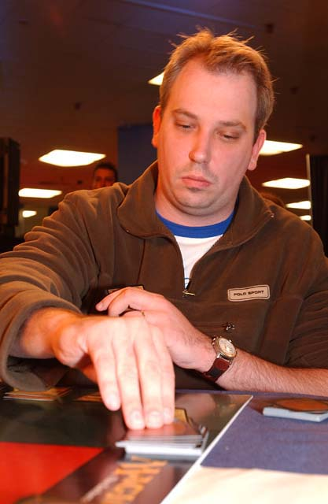
Team CMU's Aaron Forsythe is putting an end to his Pro Tour career in order to start a new life as a Media Content Manager at Wizards of the Coast. Forsythe's career highlights include making Top 4 of two Team Pro Tours in a row with teammates Andrew Johnson and Andrew Cuneo, and making Top 8 of the U.S. Nationals two years ago. Forsythe will certainly be missed from the Tour, but he is likely to remain an active part of the online Magic community as his new job will involve running an upcoming Magic web site, the details of which will be revealed in the near future.

Meridian Magic Closing Its Doors
On a sadder note, Magic's premier digest site MeridianMagic.com has closed its doors for the second time.

MTGNews.com editor Ray Yu, as a free service to the Magic community, hosted Meridian Magic. Ray was no longer able to provide his resources to MM, and the site's owner Cathy Nicoloff decided to close it for now rather than move to a different server. Meridian Magic was closed once before, then returned after about a six-month sabbatical. There is some possibility of it making another comeback in the future.

Magic Trivia
Last week's question:
Who is the top money-earner on the Pro Tour, and what is the approximate total of his lifetime winnings?
Although many have said that Kai Budde is the best player in the game now, Jon Finkel still leads the money-earner's pack by having won very close to a quarter of a million dollars. Budde is approaching 150k, while Rubin, Mowshowitz and Rose round up the elite group of players who earned over 100k. I am chugging along at around 50k. Here is the list of top 10 money earners in the game. Special thanks to Andy Heckt for providing this information.
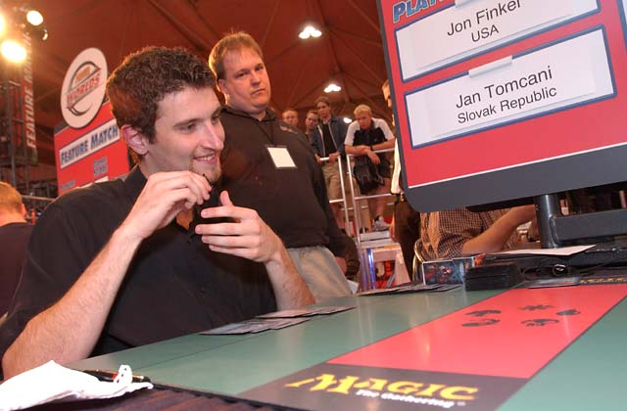
Jon Finkel $249,227
Kai Budde $144,425
Ben Rubin $119,470
Zvi Mowshowitz $108,320
Kyle Rose $104,225
Mike Long $96,202
Chris Benafel $93,850
Tommi Hovi $93,780
Darwin Kastle $90,627
Bob Maher, Jr. $82,377
New Question:
(sumbitted by Andrew Levine)
Your opponent is playing first in a normal Type I game. On her first turn, she plays a basic land and does nothing else. When your first turn begins, you are already at 24 life. How did you accomplish his?
Please do not email answers to me. Correct answer will be posted in the next column.

Correction
In the last column I talked about the German Revised edition misprints, mentioning Drudge Skeletons with a picture of a Swamp, and Forest with an artwork from a Planes. Stefan Wrammerfors wrote in to remind me that there were two other misprints in that set:
Revised WB ('95) German Mana Barbs with Sedge Troll picture
Revised WB ('95) German El-Hajjaj with Warp Artifact picture
He also recommended the following web site for a comprehensive list of available misprints: members.tripod.com/~squt/MainError.html

Bad Play of the Week
Reported by Sheldon Menery:
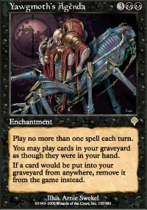
"I was playing in Alaska's final Standard tournament before Odyssey becomes legal. I was playing a Fires variant. My opponent was playing a white-black good stuff deck. A few turns before, he had played Yawgmoth's Agenda, and was just beginning to gain control of the board. If I couldn't kill him next turn, I would probably lose. He had a Death Grasp in his graveyard and 10 land in play. It wouldn't kill me, but it would give him the life he needed to survive a few more turns. Then he decided to turn up the heat and get a few extra points of life. He played Dark Ritual, then tapped the rest of his mana. He then announced Death Grasp (from his hand - come to find out he had two more), bringing me down to 1 (or so he thought). I reminded him of the Agenda's restriction on one spell per turn. He got rather red and conceded the game."
Got an interesting news story, comment, play of the week, or Magic trivia to report? Please e-mail me at ashv80@hotmail.com.

